16.2. Provisional bifurcation stenting steps

Both main vessel (MV) and side branch (SB) are wired. SB lesion preparation is usually avoided to minimize the risk of dissection that would require stenting.

- Deliver MV stent
- Deploy MV stent, jailing the SB wire
- POT (Proximal Optimization Technique
- Assess SB
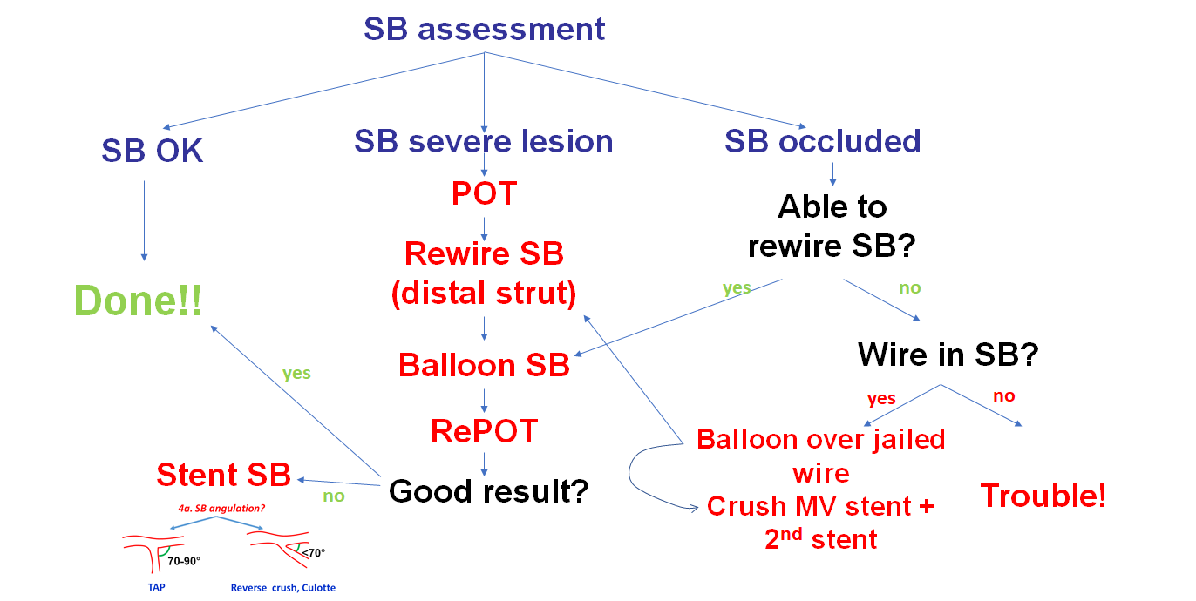

  - SB OK (physiologic assessment helpful): DONE!
  - SB with severe lesion (but not occluded): Rewire SB through distal strut, Balloon SB (or kissing balloon inflation), RePOT. If suboptimal results with balloon, stent SB.
  - SB occluded:
- Able to rewire: balloon SB (or kissing balloon), RePOT, RePOT, stent SB if suboptimal result obtained.
- Unable to rewire:
  - If SB wire in place: crush MV stent, followed by DK crush or culotte (MV becomes the SB).
  - If no SB wire in place: Consider retrograde crossing if feasible – may have to leave SB occluded.

